Europeana Learning Scenario

Title: Plastic language elements: shades and tones
Author(s): Miricioiu Carmen Alexandra
Licenses
- Attribution ShareAlike CC BY-SA. This license lets others remix, tweak, and build upon your work even for commercial purposes, as long as they credit you and license their new creations under the identical terms. This is the license used by Wikipedia, and is recommended for materials that would benefit from incorporating content from Wikipedia and similarly licensed projects.
Subject
Visual arts and practical skills
Specialized pedagogical practice
English language
Optional discipline: informatics
Topic
Vincent Van Gogh
Integration into the curriculum
Content undergoing learning is part of the primary curriculum.
Also, the proposed activity was carried out within the pedagogical practice, for high school students, from the pedagogical profile.
The proposed content also exercises the linguistic skills of students, but also those related to information technology.

The lesson addresses themes that belong to the school curriculum as follows:
- Plastic language elements: shades and tones
- Observation and involvement in the realization some school activities or extracurricular (for students participating in pedagogical practice)
Aim of the lesson
- Engaging students in exercise-exploring the links between keywords and plastic compositions, sculptures, photographs, etc. (subject of composition / work)
- Compositional composition according to originally established rules, surface or a plastic space with the help of language elements
- Assistance in teaching activities led by teachers / educators and solving by this has some current problems; record observations in the practice book
- Participate in the analysis of lessons and other activities assisted
- Serving children's behavior during lessons
Trends
Mobile Learning
Collaborative Learning
Student Centered Learning
Age of students
10- 11
Time
Preparation time: 3 h
Teaching time: 2x 45 min
Teaching materials and tools
Online:
https://www.mentimeter.com/s/2f4deb255e3e71823ebf5e23a5a36312/4b2a5af17b56/edit
https://www.youtube.com/watch?v=G7Dt9ziemYA
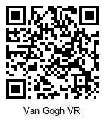
https://www.europeana.eu/portal/en/
https://www.jigsawplanet.com/?rc=play&pid=0ae4b0e9f632
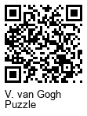
https://padlet.com/miricioiu_alexandra/5k0eem25g21o
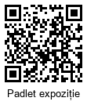

Europena resources:
http://vangoyourself.com/category/paintings/page/3/
Barcode images for Europeana
https://www.europeana.eu/portal/en/record/90402/SK_A_3262.html?q=Van+Gogh#dcId=1550427657518&p=1
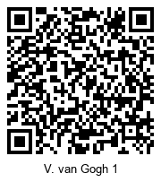
https://www.europeana.eu/portal/en/record/92034/GVNRC_VGM01_d0420.html?q=Van+Gogh#dcId=1550427657518&p=1
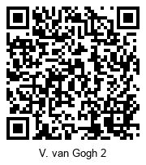

https://www.europeana.eu/portal/en/record/2022608/MH_SS_46686.html?q=Van+Gogh#dcId=1550427657518&p=3
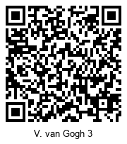
https://www.europeana.eu/portal/en/record/2048047/Athena_Plus_ProvidedCHO_Institutul_Na_ional_al_Patrimoniului_0AC21DE897434B4B928875FAA694DA5F.html?q=Van+Gogh#dcId=1550427657518&p=1
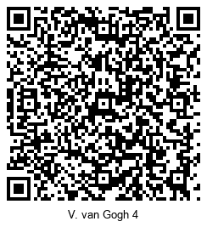
https://www.europeana.eu/portal/en/record/2064137/Museu_ProvidedCHO_Bildarchiv_Foto_Marburg_obj00074689.html?q=Vincent+van+Gogh#dcId=1550427657518&p=71
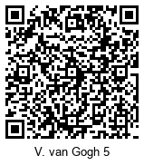

https://www.europeana.eu/portal/en/record/2064137/Museu_ProvidedCHO_Bildarchiv_Foto_Marburg_obj00074705.html?q=Vincent+van+Gogh#dcId=1550427657518&p=71
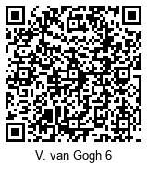
national symposium participation - https://scoalagimnazialamihaiviteazul.blogspot.com/p/simpozion-national-o-scoala-pentru.html
Offline:
VR glasses, phone, barcodes, videos, paintings made by Vincent van Gogh, VanGoYourself application, Mentimeter application, i-nigma application, graphic organizer, PhotoGrid, Padlet, watercolors, brushes, drawing sheets, water
21st century skills
Critical thinking
Creativity
Collaboration
Communication
Technology literacy
Activities

Name of activity | Procedure | Time
THE FIRST HOUR
Evocation  Mentimeter | The students are organized by groups.  A discussion is taking place to update their knowledge. The key terms are SHADES, TONES.  Tone refers to a blending color with white or black (which results in the scale or tonal scale) and the hue refers to mixing a color with another color or even more color.  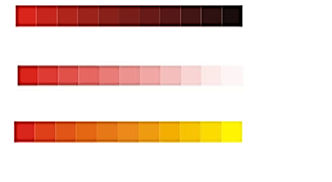  A triggering question is addressed: How would the world be free of tones and tones? And respond using the Mentimeter application.  https://www.mentimeter.com/s/2f4deb255e3e71823ebf5e23a5a36312/4b2a5af17b56/edit?  A discussion is being held on the basis of the responses issued.  The topic, purpose and objectives of the lesson are announced. | 10min
i-nigma  Vincent van Gogh | Students are divided into four groups.  Two of the groups receive VR glasses, a telephone and a barcode. Their task is to watch the video and identify the tones, shades present in the video being watched.  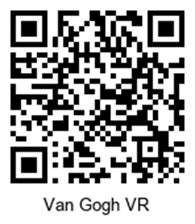  The other two groups are receive a bar code (paintings made by Vincent van Gogh). They have the task of accessing the images and identifying tons, nuances and notes, at least one of them.  Barcode requires scanning) What did you find out?  After 10 mines, a rotation is done, and tasks are exchanged. Workbooks remain on the table and fill in on these further. | 30 min
Conclusions  after the first hour | The activity ends with the completion of the card:  I found out................................................ .................................................. ..........................  It was good (about doing business) ... ....................................................................................  I think (what could be improved) ......................................... .................................................. | 5 min
THE SECOUND HOUR
Setting anchors | Students receive a barcode and, in teams of 2, with the Europeana application VanGoYourself, recreates paintings by Vincent Van Gogh, in which they are the characters.  Refreshes students' knowledge and penetrates to the next organizer.  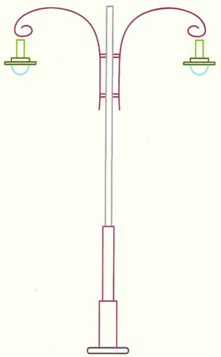 | 5 min
Conducting learning | I have proposed to the students to reproduce the Van Gogh paintings, the paintings that they have chosen for VanGoghYourself or or the paintings that they have create with the application VanGoghYourself.  The stages of work are presented and the evaluation criteria are established.  Activity can be done individually or in teams of two children.  You must use at least 3 color tones and 3 shades.  After completion of the work, it is analyzed on the basis of the criteria initially set.  Afterwards, it is proposed to the students to make collages of 2 to 3 paintings that they would buy. Collages are made with the PhotoGrid application and uploaded to the next paddle.  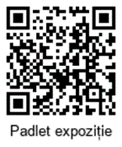 | 35 min
Reflection | It returns to the triggering question. It is discussed on the basis of this. Try to identify if opinions have changed. | 5 min

Assessment
The first hour:
I suggest a discussion of debrid:
What did you have to do?
What did you feel?
What have you seen?
What have you heard?
What did you find out? / What did you notice?
What did you mean, every experience?
What kind of life you can resemble? Why?
Each student receives the next barcode and with the Jigsaw Planet application they make the given puzzle. After that, now individually, it identifies a tone / shade in the image obtained. Note the answer on a postit.
After completing the assignment, the students meet in groups and discuss on the basis of the notes.
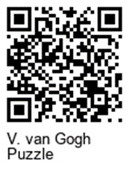
The activity ends with the completion of the card:
I found out................................................ .................................................. ......................................
It was good (about doing business) ... ..............................................................................................
I think (what could be improved) ......................................... ...........................................................
The second hour:
It is proposed to conclude the activity by collecting a constructive feedback on the activity, completing a sheet by which the students answer the questions:
What you learned? What did you feel? What would you give up?
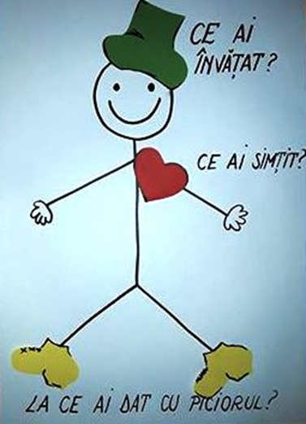

About the Europeana DSI-4 project
Europeana is Europe’s digital platform for cultural heritage, providing free online access to over 53 million digitised items drawn from Europe’s museums, archives, libraries and galleries. The Europeana DSI-4 project continues the work of the previous three Europeana Digital Service Infrastructures (DSIs). It is the fourth iteration with a proven record of accomplishment in creating access, interoperability, visibility and use of European cultural heritage in the five target markets outlined: European Citizens, Education, Research, Creative Industries and Cultural Heritage Institutions.
European Schoolnet (EUN) is the network of 34 European Ministries of Education, based in Brussels. As a not-for-profit organisation, EUN aims to bring innovation in teaching and learning to its key stakeholders: Ministries of Education, schools, teachers, researchers, and industry partners. European Schoolnet’s task in the Europeana DSI-4 project is to continue and expand the Europeana Education Community.

